
SYRIAN ARAB REPUBLIC | SYRIAN PRIVATE UNIVERSITY
Faculty of Artificial Intelligence Engineering
Software Engineering & Information Systems
GRADUATION PROJECT I / FIRST REPORT
Flower Trading Platform System
Problem and Objectives • State of the Art • Proposed Solution
Chapter One: Theoretical Study

PREPARED BY | SUPERVISED BY
Ahmad Raghib Al-Sayel | Dr. Kadan Aljouma
October 2026
REPORT OVERVIEW

Report Summary
This report introduces the Flower Trading Platform System and explains the problem it is intended to solve. It begins with the difficulties of handling flower orders through calls or scattered messages, then sets out the project objectives, looks at comparable online services, and outlines a possible system design. The theoretical chapter explains the concepts behind that design.
At this stage, the aim is to make the project clear enough to discuss and develop, not to present a finished website. The diagrams describe a proposed workflow. Features that depend on external services or further testing are kept separate from the basic system scope.
Stage-one boundary: Payment gateways, delivery-service integration and image-based AI search are discussed as possible features. They should not be described as completed until they have been implemented and tested.

How the Report Is Organized
SECTION | CONTENTS
Part I: Project definition | Problem and objectives, state-of-the-art review, proposed solution, block diagram and flowchart.
Chapter One: Theory | E-commerce, user roles, databases, MVC, requirements, security and iterative development.
Conclusion and sources | A short conclusion and the project materials used in preparing the report.
PART I / PROJECT DEFINITION

1. Problem Statement and Objectives

1.1 Background
Ordering flowers is usually tied to a particular occasion or delivery time. In a small shop, a customer might ask about a bouquet through a message, agree on the price by phone, and then contact the seller again to check whether the order is ready. Product availability, order details and delivery arrangements may be recorded in different places.
This creates problems on both sides. Customers do not always know what is available or where their order stands. Sellers have to repeat information and keep track of changes manually. The project focuses on connecting these steps rather than simply putting a flower catalogue online.

1.2 Engineering Problem
Main question: How can a web-based system with clearly defined user roles bring product information, inventory and order records together so that customers, sellers and administrators can work through the same reliable process?

1.3 Main Aim
To analyse and design an online platform that makes flower ordering easier for customers and gives sellers a more organized way to manage products and incoming orders.

1.4 Specific Objectives
• Present flowers and bouquets with useful photographs, prices and descriptions.
• Let customers register, search the catalogue, use a cart and submit orders.
• Give sellers or farmers tools to update listings, stock and order details.
• Provide administrative control over accounts, roles and permissions.
• Store product and order data in a structured database.
• Use an MVC-based design so the application can be maintained and extended.
• Study later options for delivery tracking, payments and image-based search.

1.5 Scope of This Report
The first report covers the problem, a preliminary comparison with other services and the proposed design. It does not claim that the planned functionality has been built or evaluated.
PART I / STATE OF THE ART

2. State of the Art

2.1 Similar Online Services
Several online services already offer flower and gift ordering. The project materials discuss BloomNation, Çiçeksepeti and LVLY as examples. They are useful references because they show different ways of presenting flowers, connecting buyers with sellers, and organizing checkout and delivery information. The aim here is to learn from their structure, not to copy one website.

2.2 Preliminary Comparison
SERVICE | POINTS NOTED IN THE PROJECT MATERIALS | LESSON FOR OUR DESIGN
BloomNation | Local florist listings, product photos and options for customization. | Give each seller clear product pages and manageable order information.
Çiçeksepeti | A range of flowers and gifts with ordering and delivery-focused pages. | Keep categories easy to browse and the ordering steps understandable.
LVLY | Simple storefront and several payment options in the seminar comparison. | Avoid an overloaded interface and show important purchase details early.
This is a review of the uploaded project drafts and presentations, not an independent test of the companies. Their features, performance and service limits may change over time.

2.3 What the Project Adds
The useful direction for our project is to place the customer experience and the seller’s daily work inside one system. A good-looking product page is only part of the solution: stock quantities, order decisions and user permissions also need to be recorded consistently.

2.4 Points to Carry into the Design
• Keep the catalogue straightforward and easy to search.
• Let authorized sellers update their own product and stock data.
• Show clear order states to both customers and sellers.
• Keep administrator permissions separate from ordinary user actions.
• Design optional integrations so they can be added later without changing the entire system.
PART I / PROPOSED SOLUTION

3. Proposed Solution

3.1 How the System Would Work
The proposed platform is a website shared by customers, sellers or farmers, and administrators. Sellers publish flowers and bouquets and keep their listings up to date. Customers can browse the catalogue, add items to a cart and submit orders. Administrators manage accounts and access rights. The different parts use the same data so that one action does not have to be entered again somewhere else.

3.2 High-Level Block Diagram
Figure 1 shows the proposed layers of the application. Users interact with the website; controllers handle their requests; and the data layer keeps the records needed by the system. It is a design sketch, not a diagram of a running deployment.
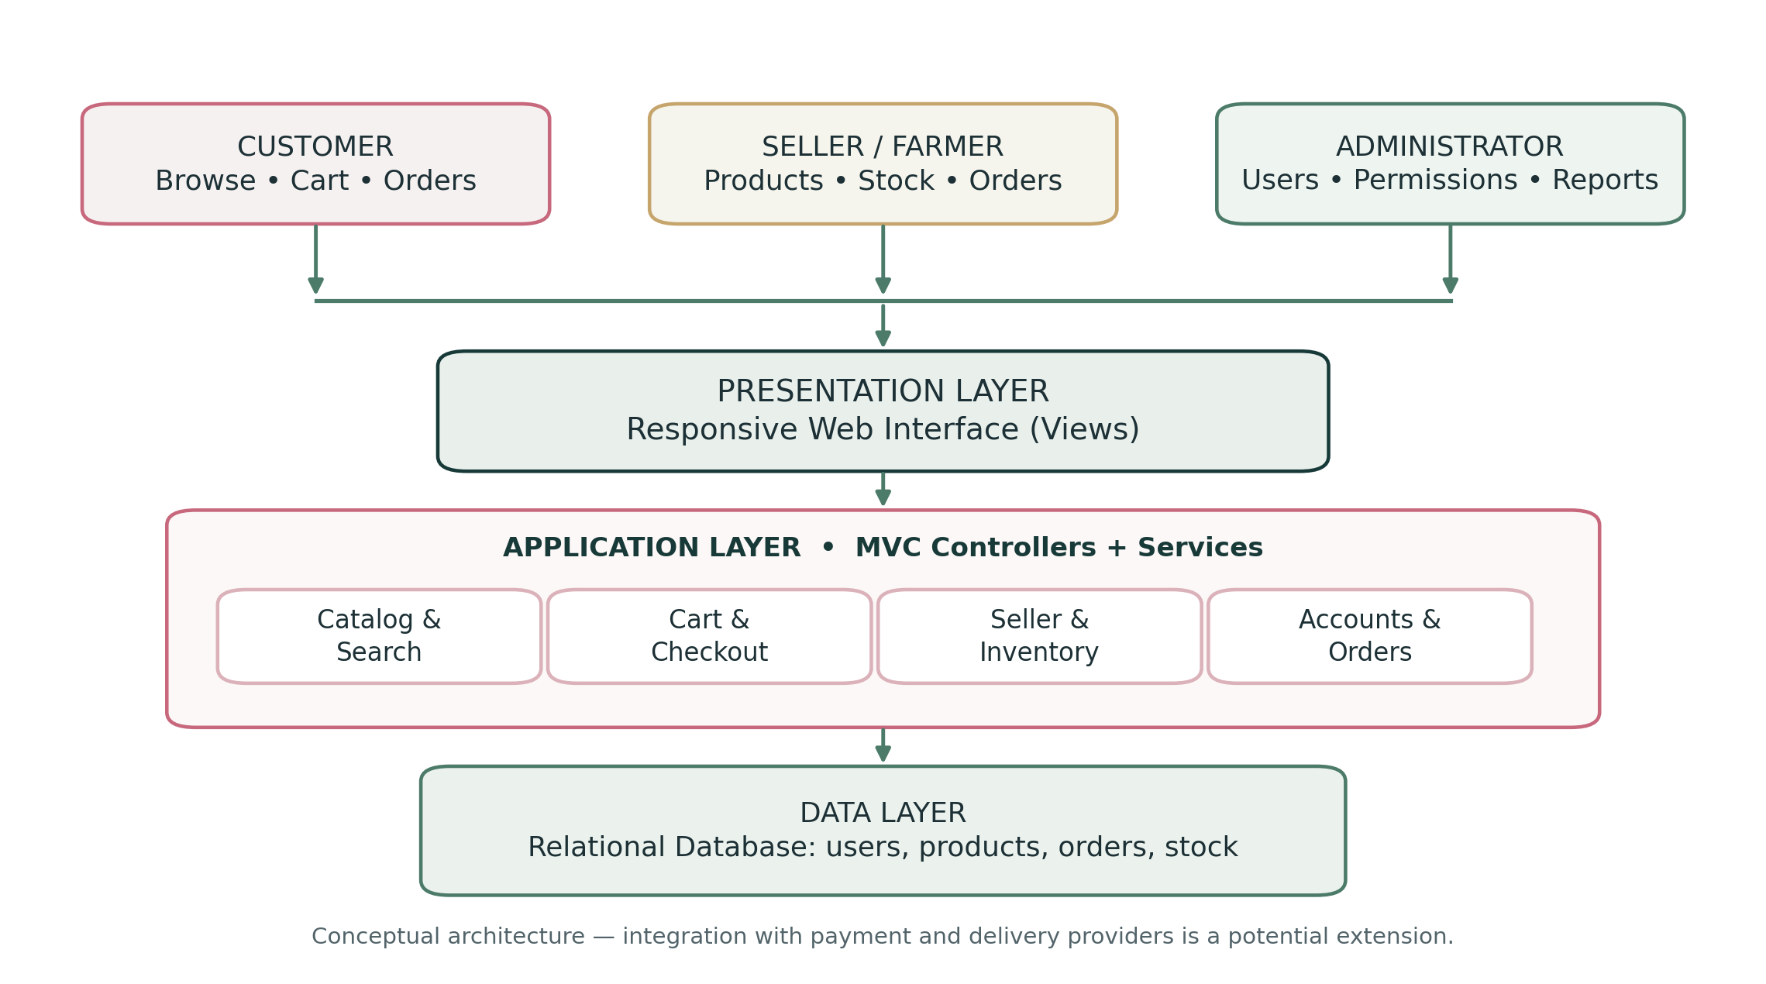
Figure 1. Proposed high-level block diagram.

3.3 Main Components
COMPONENT | FUNCTION
Catalogue and search | Show flower images, descriptions, prices and search results.
Cart and orders | Collect item selections and create order records.
Seller management | Update products and stock and review incoming orders.
Accounts and roles | Control sign-in and actions available to each user type.
Database | Keep consistent records for users, products, orders and status updates.
PART I / ORDER WORKFLOW

4. Order Flowchart
Figure 2 follows a customer order from product selection to an updated order status. After browsing the catalogue, the customer confirms the cart and submits an order. The system checks availability. If the item is unavailable, the customer needs to change the selection; otherwise, the seller reviews and prepares it. This is a simplified flow, to be refined when the detailed requirements are agreed.
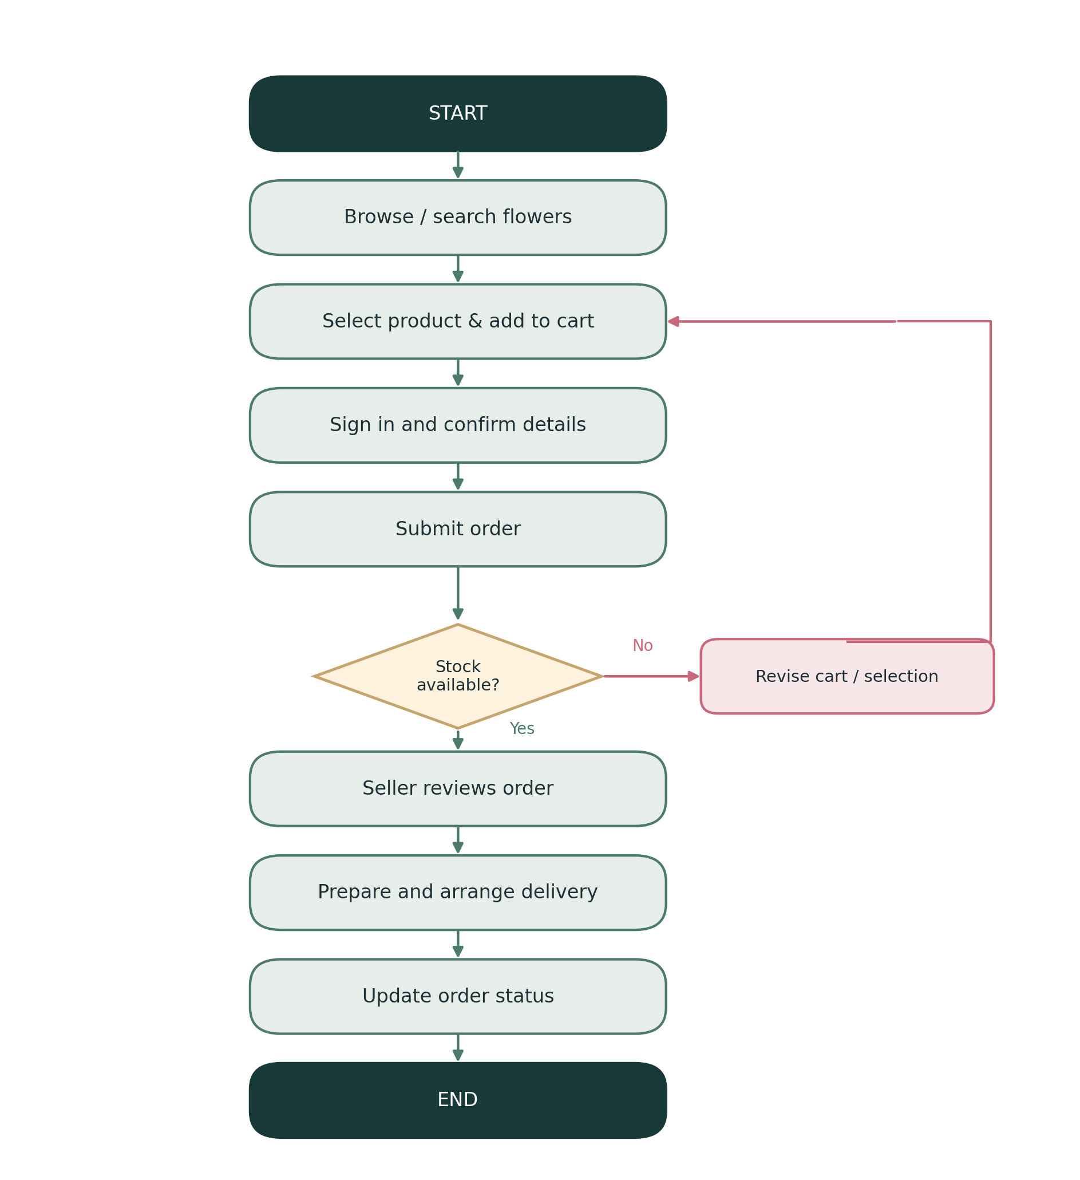
Figure 2. Simplified flower-order flowchart.
CHAPTER ONE / THEORETICAL STUDY

Chapter One: Theoretical Study

1.1 Introduction
Before starting the implementation, we need a clear idea of the concepts used in the platform. E-commerce, information systems, user permissions and application architecture are not separate topics here: they explain why the ordering process must be designed as a connected system.

1.2 E-Commerce and Online Marketplaces
E-commerce is the buying and selling of products through digital services. An online marketplace can bring several sellers and their product catalogues into one place. In the flower platform, customers would be able to compare bouquets, while each seller remains responsible for the products they offer.

1.3 Information Systems and Data Flow
An information system combines people, procedures, software and stored data. For example, when a customer submits a flower order, the website sends the selected products and customer details to the application. The application checks the information, stores the order and returns a response to the right users.

1.4 User Roles and Permissions
Role-based access control (RBAC) limits actions according to the user’s role. A customer should not edit a seller’s stock, and a seller should not have unrestricted access to administrator functions.
ROLE | MAIN ACTIONS
Guest | Browse available products and create an account.
Customer | Search, save favourites, use a cart and manage own orders.
Seller / Farmer | Manage own listings, stock and incoming orders.
Administrator | Manage users, sellers, roles and permissions.

CHAPTER ONE / ARCHITECTURE AND DATA

1.5 MVC Architecture and Database Design

1.5.1 Model–View–Controller
The MVC approach separates the application into three parts. The Model represents data and the rules that apply to it. The View is what users see and interact with. The Controller receives requests and coordinates the necessary work. This separation matters when the same platform has customer pages, seller tools and an administration area.
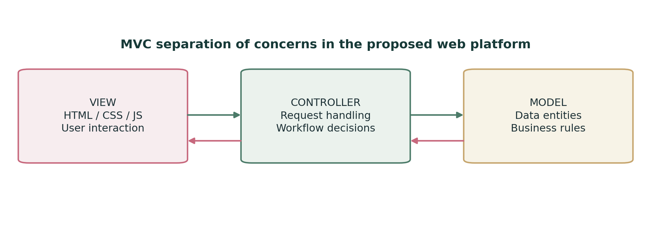
Figure 3. MVC responsibilities in the proposed website.

1.5.2 Relational Database
A relational database organizes data into related tables. Rather than placing every piece of information in one record, the platform can keep users, sellers, products, orders and order items separate. This also allows an order to retain its original product price even if the catalogue price changes later.
ENTITY | EXAMPLE INFORMATION
User | ID, name, login details and role.
Seller | Store name and associated user account.
Product | Name, description, price, stock and seller reference.
Order | Customer reference, order date and status.
Order item | Product reference, quantity and price at purchase.

1.5.3 UML and System Models
UML diagrams provide different ways to describe a system. A use-case diagram identifies what users need to do; an activity diagram shows the steps of a process; a sequence diagram shows the order of interactions; and a class diagram describes the main software structures. An ERD can then support the database design. The source materials include examples that can be refined in the next stage.
CHAPTER ONE / REQUIREMENTS AND DEVELOPMENT

1.6 Requirements and System Quality

1.6.1 Functional and Non-Functional Requirements
Functional requirements describe tasks the system must perform, such as adding a flower, searching the catalogue or submitting an order. Non-functional requirements deal with qualities such as ease of use, access control, reliability and maintainability. Both types should be specific enough to test later.

1.6.2 Iterative Development
The seminar presentation proposes an iterative approach. Instead of attempting every feature at once, the work can be divided into smaller versions. An early version might cover accounts and product listings. Later iterations could add the cart, order processing, seller tools and administrator permissions. Testing each version makes it easier to find mistakes before the project becomes too large.

1.6.3 Security and Reliable Orders
The website would hold account information and order records, so users need secure authentication and checks on what they are allowed to do. Form input should be validated, and sensitive data should be protected. Order creation and stock updates also need to agree with each other; otherwise, a customer may receive an order confirmation for an item that cannot be supplied.

1.6.4 Usability
Flower images, prices, categories and the steps of checkout should be easy to understand on both computers and phones. Clear error messages are important, especially when information is missing or an item is no longer available. The aim is to make the common tasks straightforward, not simply to produce attractive pages.

1.6.5 Features for Future Study
The uploaded project material also proposes searching for flowers using images, sending order updates and integrating payment or delivery services. These ideas are worth studying, but they require their own requirements and testing before they can be treated as implemented features.
Chapter summary: The project is built around a role-based website and a consistent database. MVC, requirements analysis, system models and iterative testing provide a practical basis for the next design and implementation steps.

CONCLUSION AND SOURCE NOTES

Conclusion
This first report has defined the problem behind the Flower Trading Platform System and the main goals of the proposed solution. Looking at comparable services helped identify useful design ideas, while the block diagram and flowchart made the intended system easier to explain. The theoretical chapter connects those ideas to the software concepts that will be needed during development.
The next step is to agree on detailed requirements, refine the use cases and data model, and build a small version that can be tested. As the project develops, it will be important to distinguish planned features from features that have actually been completed.

Project Materials Used
FILE | INFORMATION USED
FlowerStore English project draft (Word) | Project background, problem, objectives, initial comparisons, models and technical concepts.
Flower Store seminar (PowerPoint) | User roles, requirements, MVC and iterative development method.
Flower Store - Copy presentation | Supporting system requirements, diagrams and platform comparisons.
First-report instruction image | Required structure: problem/objectives, state of the art, solution diagrams and theoretical chapter.

